User Requirements Specification

Group 5

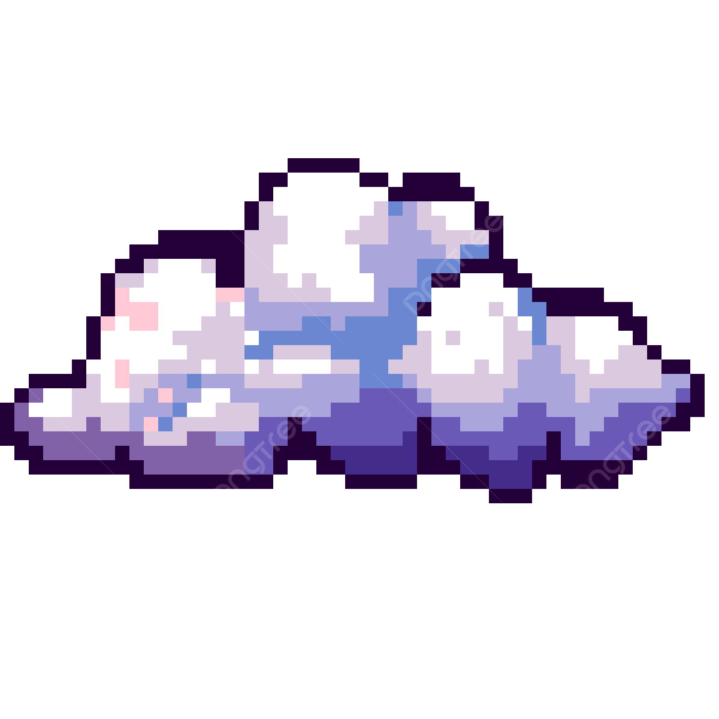

**Student Names:**Nicolas Casuso, Christian Fuguet Robazetti, Himar Marichal Delgado

**Class:**I3-CB-CMK

Table of Contents/Nicolas

**Requirements 2**

**Introduction/Nicolas 3**

**Product Vision 4**

**User Personas 5**

**User Story Mapping/Nicolas 5**

1. Backbone (High-level project goals): 5

2. User Activities (Main functionalities users will interact with) 6

1. Store & Manage Files 6

2. Synchronize Data 6

3. Manage Versions & Backup 6

4. Register & Login 6

5. Access Files Anywhere 6

6. Monitor Cloud Infrastructure (Admin Role) 7

7. Security 7

3. User Tasks (Steps to complete each activity) 7

1. Store & Manage Files 7

2. Synchronize Data 7

3. Manage Versions & Backup 7

4. Register & Login 7

5. Monitor Infrastructure 7

4. Technical Activities (Infrastructure and Development Tasks) 8

1. Set Up Cloud Infrastructure (AWS S3 & RDS) 8

2. Hybrid Cloud Implementation 8

3. Deploy Web-Based Interface 8

4. Automation & Scalability 8

6. Monitoring and Security 8

Product Roadmap 9

Research & Discovery 9

Core Feature Development 9

Enhanced Features & Admin Functionality 10

Security, Compliance, & Optimization 10

Sprint Goals 11

Sprint 1 (Weeks 1-3): Requirement Gathering & Setup 11

Sprint 2 (Weeks 4-5): Infrastructure Setup 11

Sprint 3 (Weeks 6-7): Basic File Storage and Management 11

Sprint 4 (Weeks 7-8): Web Interface and Authentication 12

# Requirements

• Cover page/Nicolas

• Table of contents/Nicolas

• Introduction/Nicolas

• Product vision Chris

• User personas Chris

• User story mapping/Nicolas

• Product Roadmap

• Sprint’s goal

# Introduction/Nicolas

This project aims to develop a cloud-based storage solution, similar to Dropbox, to address two main problems: limited access to locally stored files and high upfront costs for additional storage space. Traditionally, files stored on a local device can only be accessed from that device, or through carrying an external hard drive, which can be inconvenient. Additionally, purchasing storage often requires paying for more space than needed, leading to wasted resources.

Our solution will allow users to store files both in the cloud using AWS S3(amongst other services) and on-premises at Fontys’ Infralab. The system will be accessible through a web interface, and we will use tools like Ansible and Terraform to deploy the infrastructure.

By the end of this project, we aim to have a cloud storage solution that is easy to use, scalable, and fully deployable with automation tools.

# Product Vision

Our shared vision for our product is a simple-to-use application with extensive usability. With our service, users will be able to store files safely on the cloud or on their own on premise infrastructure and access these files from anywhere in the world by using our website. Any changes to a file they upload will be visible across all of their devices and as long as they have an Internet connection, they will be able to download these files from anywhere in the world using our website. Our application will be easy to modify and expand due to its modular nature, and it will be able to interact with other applications making use of APIs.

A good application should be easy to use and its main functions should be performable with just a few clicks while still displaying at all moments information relevant to the user. This is what we strive to do; The user should have a seamless experience and all functions should be easy to find and use.

The GUI will be simple and straight-forward. All relevant information should be visible for the user at all moments and all functions should be easy to access and configure.

# User Personas

Andres:

Andres is a 17 year old finishing high school who is interested in architecture and uses programs such as Blender to make some digital building models in his spare time. He has quite a few of these models and they each occupy about ~100 MB of space. Andres only has an older Chromebook with limited space and not only is he running out of space but he is afraid his laptop is becoming too old and he might lose his models if it breaks. Andres does not like carrying around USB sticks and does not have another laptop to store these models on. By using our service he is able to store these files safely in the cloud and access them from any device connected to the Internet via our website.

Dmitri:

Dmitri is an engineer who is very privacy-aware and has some computers at home he barely uses. He does not want to use any cloud services to store his data on since he does not trust that they will not access this data eventually. He could set up a VPN server and data storage software in his devices but he does not have the time nor will to do this. By using our service he can store all of his data locally and access it via our website from anywhere in the world, without needing to rely on cloud providers that could potentially misuse his data.

Johan:

Johan is a journalist who has files with personal and very delicate information that he does not want to store anywhere outside of his own devices, but he also likes photography and has many pictures that occupy a lot of space and he does not mind storing these in the cloud. By using our service, he can store the sensitive data in his personal devices only and the non-sensitive pictures in the cloud and access all of that data from anywhere in the world without needing to worry about cloud providers accessing his more confidential files.

# User Story Mapping/Nicolas

#### **1. Backbone (High-level project goals):**

* File Storage & Sharing
* Data Synchronization
* User Authentication & Permissions
* Security and Compliance
* Hybrid Cloud Implementation
* Scalability and Cost Optimization
* Infrastructure Automation & Monitoring

### **2. User Activities (Main functionalities users will interact with)**

#### **1. Store & Manage Files**

* **User Story 1:** As a user, I want to upload my files to the cloud so that I can access them from anywhere.
* **User Story 2:** As a user, I want to manage my files (edit, delete, organize) from any device for better accessibility and control.
* **User Story 3:** As a user, I want to delete my files if they are no longer needed, ensuring I don't waste storage space.

#### **2. Synchronize Data**

* **User Story 4:** As a user, I want my files to be automatically synchronized across all my devices, so I always have access to the latest version.
* **User Story 5:** As a user, I want the option to synchronize my on-premises files with the cloud storage, ensuring data consistency between both.

#### **3. Manage Versions & Backup**

* **User Story 6:** As a user, I want access to previous versions of my files to recover from unintended changes.
* **User Story 7:** As a user, I want my files to be backed up in both cloud and on-premises storage to ensure data security.

#### **4. Register & Login**

* **User Story 8:** As a new user, I want to register on the website to create an account and use the service.
* **User Story 9:** As a returning user, I want to log in to my account securely, so I can access my files and settings.

#### **5. Access Files Anywhere**

* **User Story 10:** As a user, I want to access my files from any device using a web-based interface to ensure flexibility.

#### **6. Monitor Cloud Infrastructure (Admin Role)**

* **User Story 11:** As an admin, I want to monitor cloud infrastructure resources like AWS S3 and RDS to ensure everything is running smoothly.
* **User Story 12:** As an admin, I want to view database and infrastructure metrics in real-time using AWS CloudWatch for effective monitoring.

#### **7. Security**

* **User Story 13:** As a user, I want to ensure my files are scanned for malware when uploaded to keep my data secure.
* **User Story 14:** As an admin, I want to securely connect cloud resources using AWS Secure Connect to ensure safe data transfer.

### **3. User Tasks (Steps to complete each activity)**

#### **1. Store & Manage Files**

* Upload files through the web interface.
* Create, delete, and organize folders.
* Access files from both cloud and on-premises storage.

#### **2. Synchronize Data**

* Automatically sync files across devices.
* Ensure version history is saved in case of changes.
* Sync files between cloud and on-premises environments.

#### **3. Manage Versions & Backup**

* Access file history.
* Set up automatic backups in AWS S3 and on-premises storage.

#### **4. Register & Login**

* Register a new account using email and password.
* Log in securely using account credentials.

#### **5. Monitor Infrastructure**

* Monitor cloud resources like AWS S3 buckets and databases.
* View real-time metrics through AWS CloudWatch for system performance.

### **4. Technical Activities (Infrastructure and Development Tasks)**

#### **1. Set Up Cloud Infrastructure (AWS S3 & RDS)**

* **User Story:** As a developer, I want to deploy cloud infrastructure using Terraform to ensure scalability and automation.

#### **2. Hybrid Cloud Implementation**

* **User Story:** As a developer, I want to integrate both cloud (AWS S3) and on-premises storage to provide users with flexible storage options.

#### **3. Deploy Web-Based Interface**

* **User Story:** As a developer, I want to build and deploy a user-friendly web interface so that users can interact with the system.

#### **4. Automation & Scalability**

* **User Story:** As a developer, I want to automate infrastructure deployment using Ansible to reduce manual setup and improve efficiency.

#### **6. Monitoring and Security**

* **User Story:** As a developer, I want to set up AWS CloudWatch for real-time monitoring of storage and database performance.
* **User Story:** As a developer, I want to ensure AWS Secure Connect is used to provide safe communication between cloud resources.

### 

### 

### 

### 

### 

### **Product Roadmap**

Our product roadmap provides a high-level timeline for the development and deployment of the cloud-based storage solution. This roadmap is divided into four major phases called sprints, each focusing on specific development goals to ensure a smooth, progressive implementation of features and functionality. There arent many specifications yet because my group and I need to still discussed the infrastructure of our service. After we create one we will divide the tasks to get to our goal into the sprints to try and be always up do day.

### **Research & Discovery**

**Objectives**:

* Conduct user research to validate personas and gather insights.
* Define requirements and prioritize features based on user needs.

**Milestones**:

1. User persona validation sessions.
2. Competitive analysis report.
3. Feature prioritization workshop.

### **Core Feature Development**

**Objectives**:

* Develop core functionalities focusing on file storage and synchronization.

**Milestones**:

1. **File Storage & Sharing**
   * User Story 1: Implement file upload functionality.
   * User Story 2: Enable file management (edit, delete, organize).
   * User Story 3: Develop delete functionality.
2. **Data Synchronization**
   * User Story 4: Implement automatic file synchronization.
   * User Story 5: Develop synchronization for on-premises files.
3. **User Registration & Login**
   * User Story 8: Implement user registration.
   * User Story 9: Implement secure login functionality.
4. **Basic Security Features**
   * User Story 13: Integrate malware scanning during uploads.

### 

### 

### **Enhanced Features & Admin Functionality**

**Objectives**:

* Expand functionalities, focusing on user management, data backup, and security.

**Milestones**:

1. **Manage Versions & Backup**
   * User Story 6: Implement version history access.
   * User Story 7: Set up automatic backup systems.
2. **Admin Monitoring Tools**
   * User Story 11: Develop monitoring tools for cloud infrastructure.
   * User Story 12: Implement real-time metrics viewing using AWS CloudWatch.
3. **User Access Flexibility**
   * User Story 10: Enable web-based interface access from any device.
4. **Data Synchronization Enhancements**
   * Refine synchronization features based on user feedback.

### **Security, Compliance, & Optimization**

**Objectives**:

* Focus on improving security, compliance, and optimizing performance.

**Milestones**:

1. **Security Enhancements**
   * User Story 14: Integrate AWS Secure Connect for secure data transfer.
2. **Compliance & Security Review**
   * Conduct a comprehensive review of security practices and compliance.
3. **Hybrid Cloud Implementation**
   * User Story: Develop integration of cloud (AWS S3) and on-premises storage.
4. **Infrastructure Automation**
   * User Story: Implement infrastructure automation using Terraform and Ansible.

### **Sprint Goals**

We will break down the roadmap into bi-weekly sprints, each focused on specific goals and deliverables. Below is the outline of sprint goals:

#### **Sprint 1 (Weeks 1-3): Requirement Gathering & Setup**

* **Goals**:

-Finalize the project requirements.

-Complete user personas and user stories.

-Set up the development environment.

**Deliverables**: User Requirements Specification Document, development tools configured, and project timeline established. Project Plan v1 submission.

#### **Sprint 2 (Weeks 4-5): Infrastructure Setup**

* **Goals**:

-Continue improving documentation after receiving feedback.

-Start dividing work and design UML.

-Create a presentation of the current situation.

**Deliverables**: Presentation and UML.

#### **Sprint 3 (Weeks 6-7): Basic File Storage and Management**

* **Goals**:

-Implement basic file storage and management functionality.

-Begin working with file uploads to website.

**Deliverables**: Cloud storage system with file upload and management. Design Document. Peer review.

#### **Sprint 4 (Weeks 7-8): Web Interface and Authentication**

* **Goals**:

-Presentation of current situation.

-DEMO with basic functions.

**Deliverables**: Functional web interface with login and file storage options.

This product roadmap and sprint structure ensures that the project progresses smoothly with clear goals and deliverables for each phase of development.

